IAM Tasks

1. Create one IAM user and assign EC2 and S3 full access roles.
Objective:
The process of creating an IAM role with full S3 permissions and assigning it to an EC2 instance for command line access to S3. By following the steps outlined in this guide, you will learn how to configure the necessary #IAM role, associate it with an EC2 instance, and use command-line tools to interact with S3.

Pre-requisite:
AWS account.

Steps:
    - Create a user, Test IAM IAM users Create user
    - Select Provide user access to the AWS Management
    - Select Console password as custom password & create password
    - Click Next
    - Select Attach policies directly
    - From the permission policies, we attach policies related to full access to EC2 and S3.
    - click on create user it will create a user with the
user name, account id and password.
    - login into the aws console with user details that we have created.
    - To verify the policies that we have attached are correctly working.
    - For that, create a S3 bucket.
    - And then launch an ec2 instance and ssh into that instance with the pem key.
    - And there use the command aws s3 ls, if the CLI & now it will show the buckets that present in our S3 service.

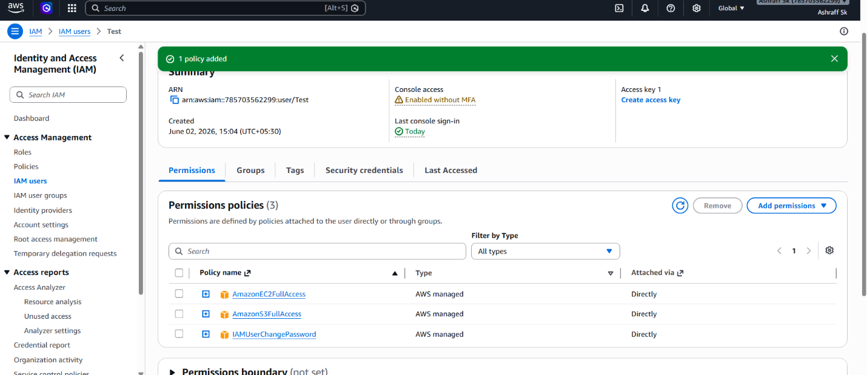

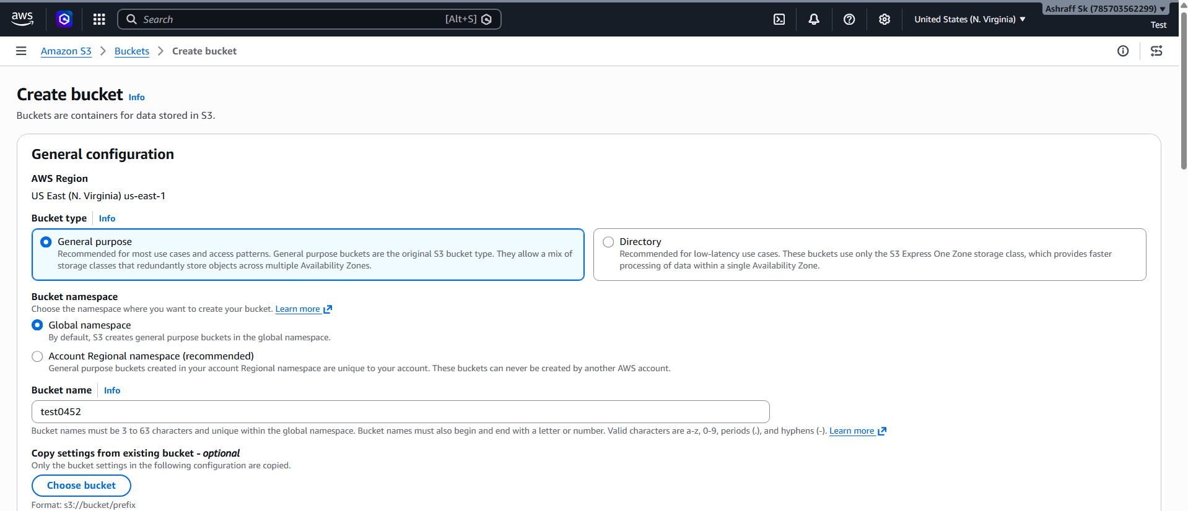
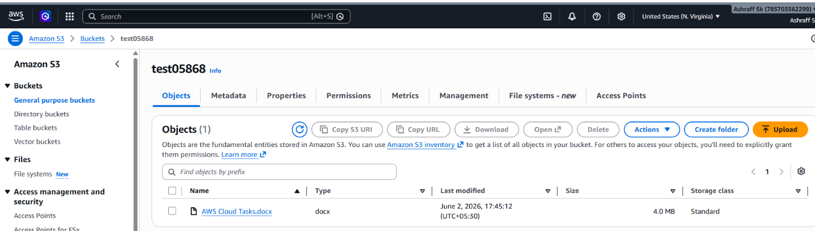
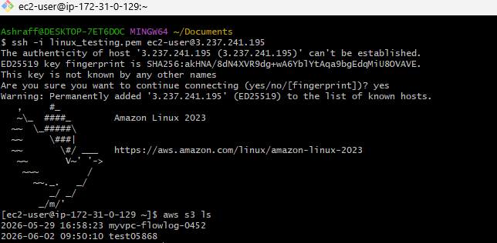

2. Create one group in IAM and assign read access for EC2.
Purpose:
The purpose is to simplify permission management
by creating an IAM group that provides read-only access to
Amazon EC2 resources for multiple users who need to monitor EC2 without any changes.

Objective:
To implement role-based access control by creating an IAM group and granting it read-only permissions to Amazon EC2 resources, allowing users to view EC2
information without modifying any resources.

Steps:
- Go to IAM service in AWS.
- In IAM service search for the user groups in the navigation pane.
- In that page, click on create group.
- Mention the group name and attach the policies that
Required to give EC2 read access only.
- Search for that policy and attach that policy to the
group.
- Click on create group and it will create a user
group for us.

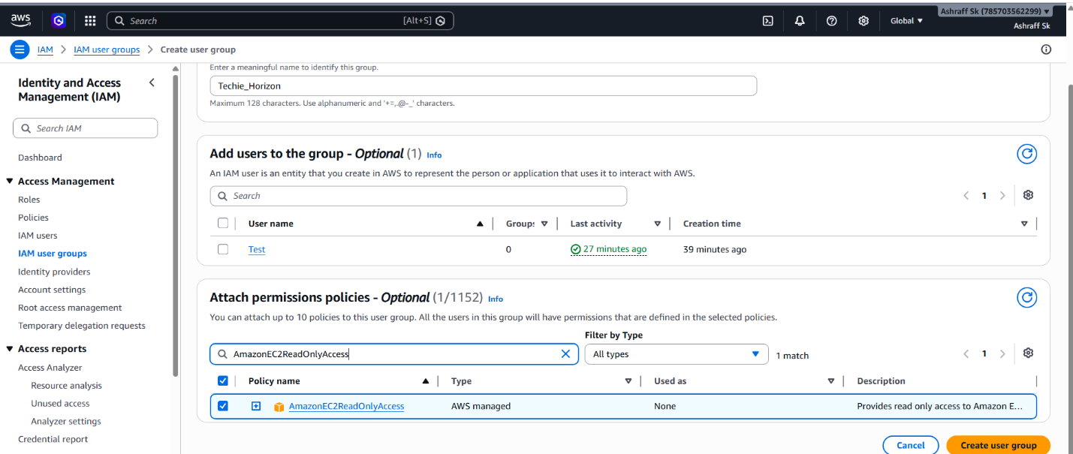

Conclusion:
A centralized IAM group provides secure, read-only access to Amazon EC2 resources, enabling users to monitor and review infrastructure.

3. Create a new user named "Devops" and add to the group created in task 2.
Purpose:
To provide the Devops user with the permissions already assigned to the IAM group without assigning permissions directly to the user.
Objective:
To create an IAM user named Devops and assign
the required permissions by adding the user to the existing IAM group, thereby implementing centralized and role-based access management.

Steps:
- Create a user Devops and add that user to the existing group that we have created in task 2.
- Then login that user with the credentials and try launch
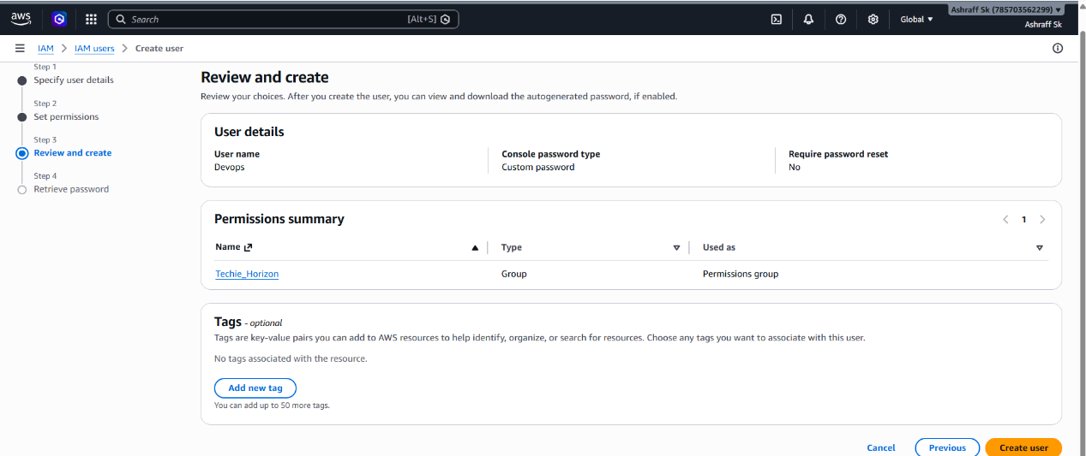

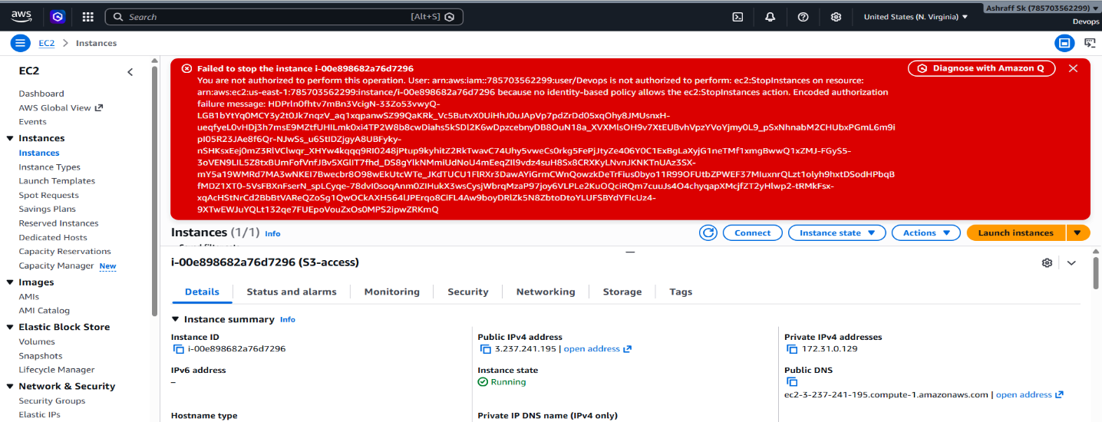
4. Write a bash script to create an IAM user with VPC full access.
Steps:
- In Git bash, configure the aws cli by aws configure command.
- After configuration, create a bash file to write a
script to create a user with VPC full access.
- Change the permission of that .bash file.
- Then verify the user is created or not in AWS console.
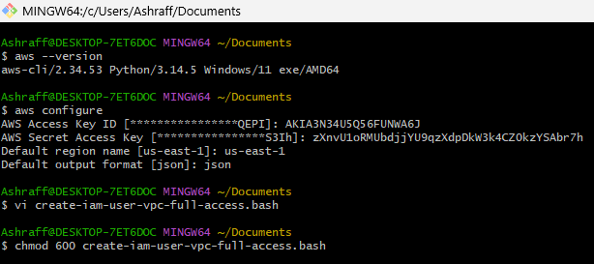
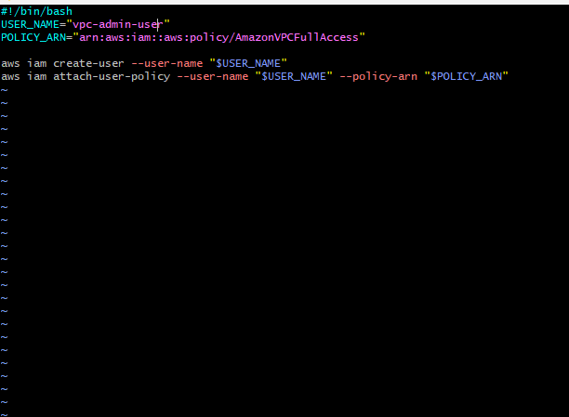
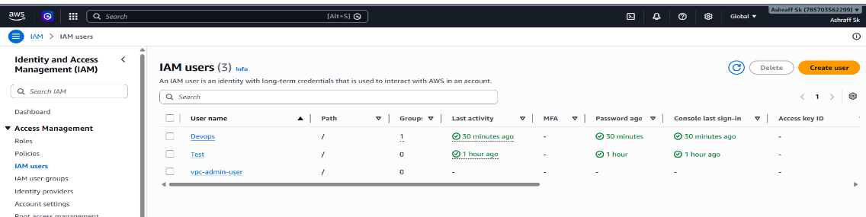

Conclusion:
To automate the creation of an AWS IAM user and assign permissions for full management of Amazon VPC resources, ensuring consistency & efficiency we use bash scripting.

5. Create an IAM policy to allow EC2 access for a specific user in specific regions only.
Objective:
To create and apply an IAM policy that restricts a specific user’s Amazon EC2 access to designated AWS regions, ensuring secure, compliant and controlled resource management.
Purpose:
To enforce region-based access control by allowing a specific IAM user to access and manage Amazon EC2 resources only in specific AWS regions & restricting access to all other regions.

Steps:
- Create a custom policy.
- Open AWS Identity and Access Management (IAM).
- Navigate the policies -> create policy.
- Select the JSON tab
- Click NEXT and provide a policy name
- Create the policy
- Go to users and select the target user
- Choose add permissions -> Attach policies directly.
- Select created policies & attach that policy to user.
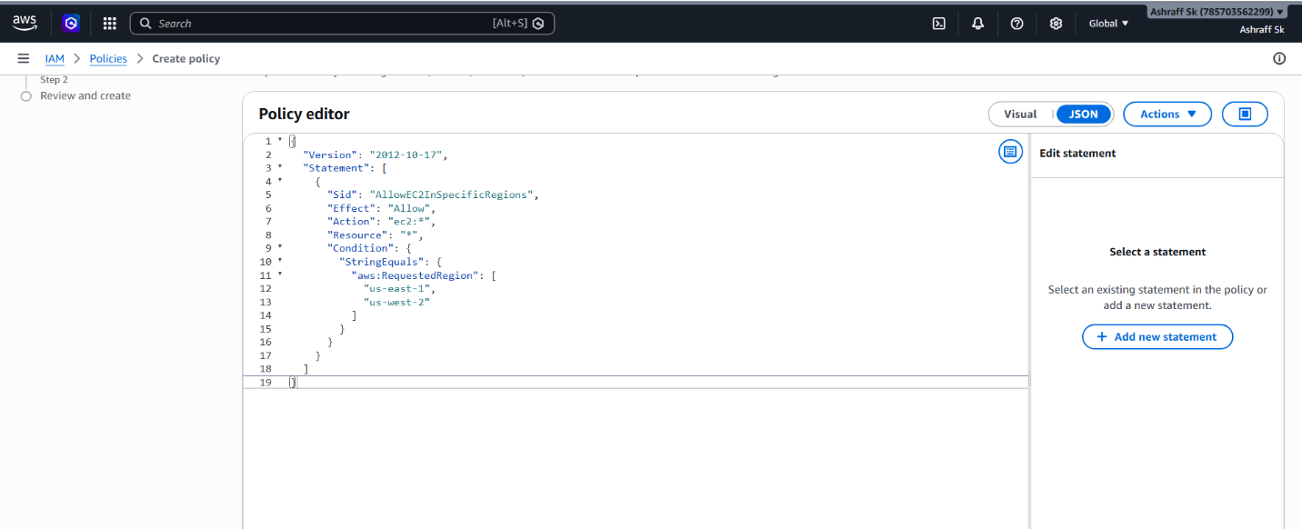
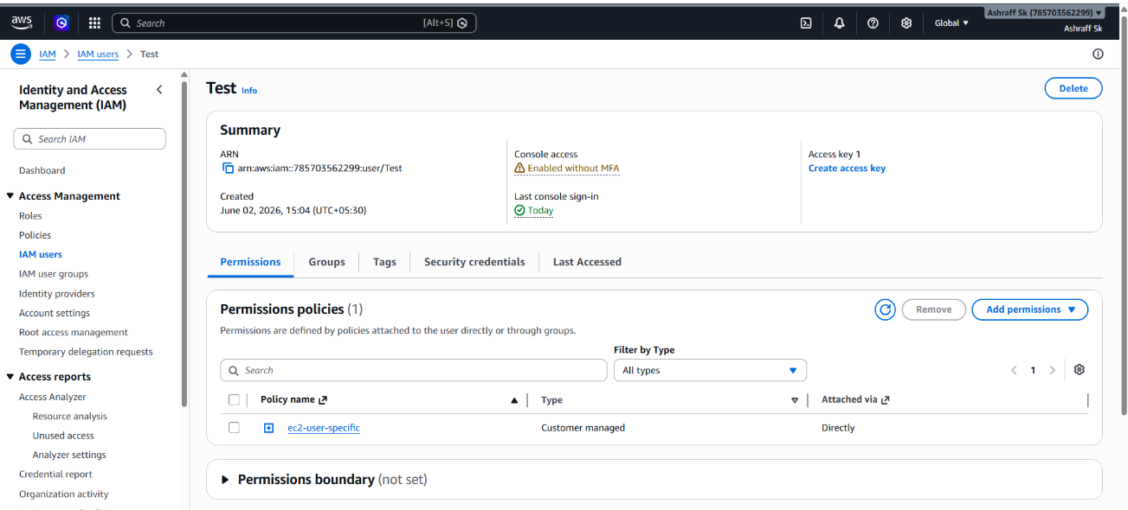

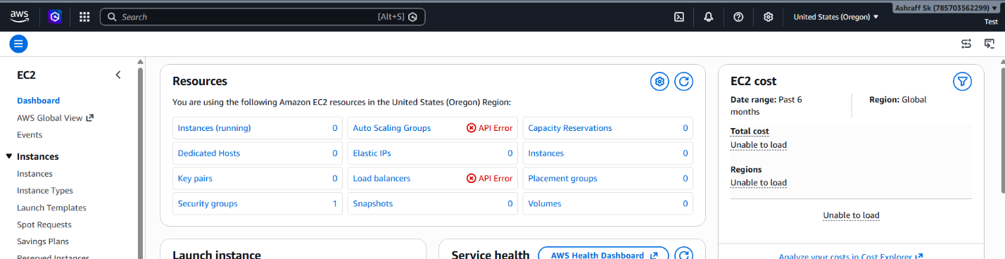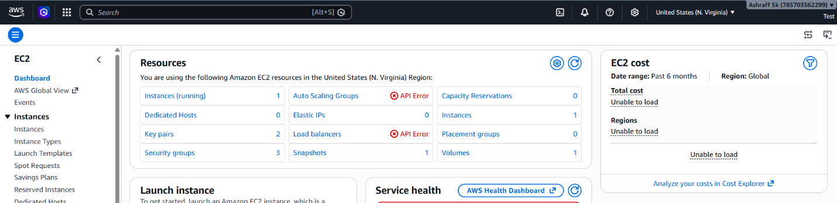
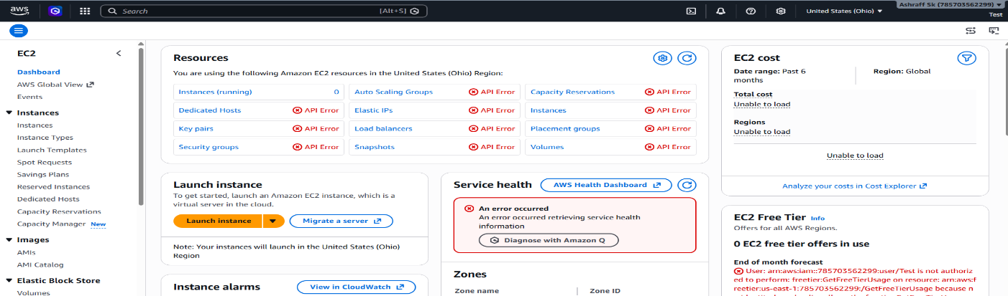
6. We have two accounts: Account A and Account B. Account A user should access an S3 bucket in Account B.
(Collaborate with a team member and execute this. This is mostly asked in every interview.)

Purpose:
To enable secure cross-account access
so that a user in Account A can access data stored in an Amazon S3 bucket owned by Account B without sharing account credentials.

Objective:
To configure secure cross-account access so that a user in Account A can access and perform authorized operations on an Amazon S3 bucket located in Account B while maintaining proper security controls and ownership boundaries.

Prerequisite:
    - Access to two AWS accounts:
Account A (Source Account)
Account B (Target Account)
    - IAM permissions to create users and manage S3 bucket policies.
    - AWS Management Console access
Steps:
- Log in to AWS Account A.
- Navigate to IAM Service.
- Select Users.
- Click Create User.
- Enter the user name: s3-test
- Created and attached an IAM policy to the user in Account A
- Configured a Bucket Policy in Account B allowing access to Account A.
- Saved and validated both policies.
- Accessed the S3 bucket and verified object visibility.
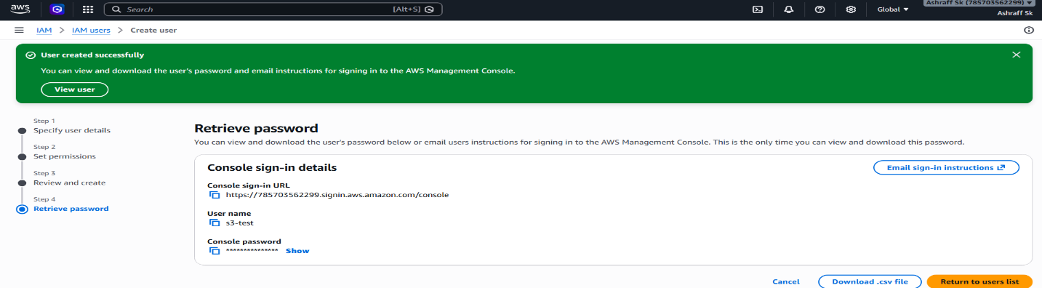
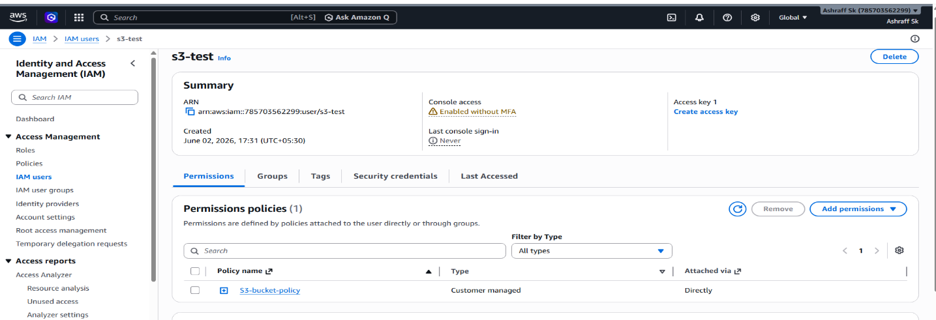

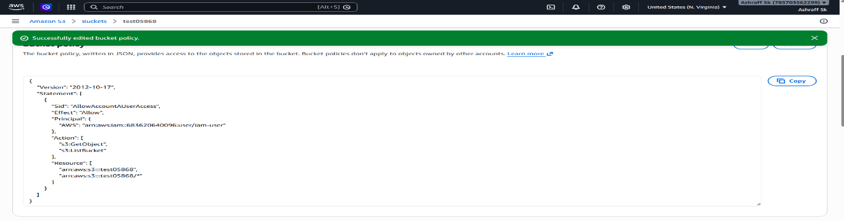
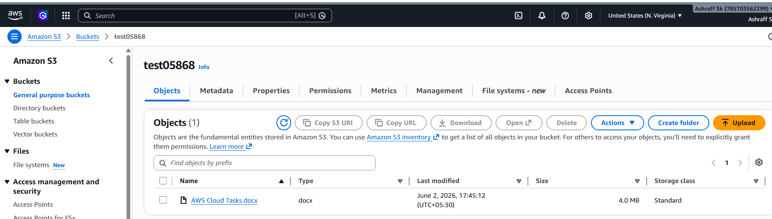
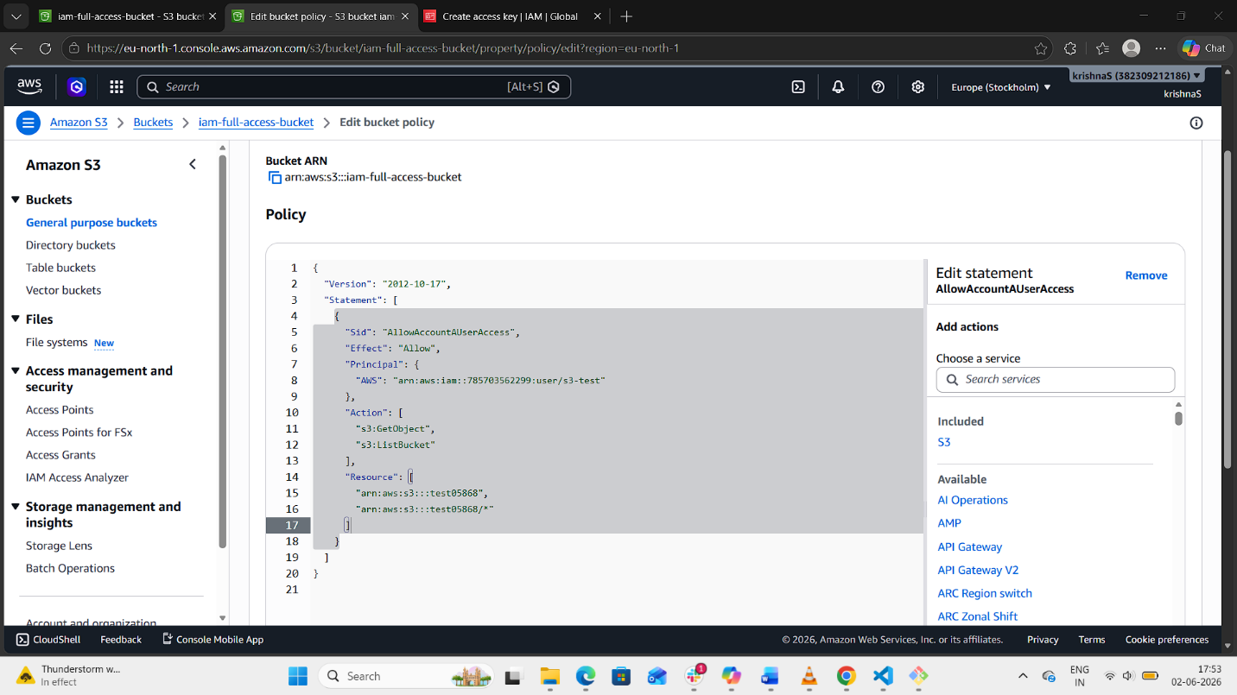
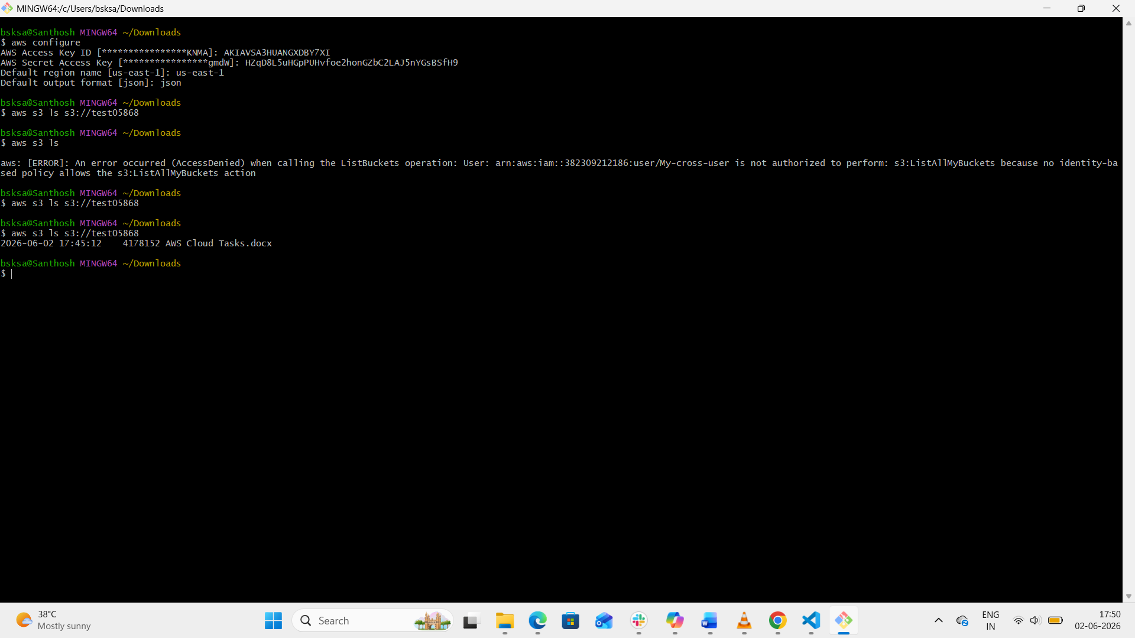

Conclusion:

A user in Account A can securely access and interact
with the specified Amazon S3 bucket in Account B according to the defined permissions, while Account B maintains full ownership, control, and security of the bucket and its contents.

